**TUGAS MINGGU KE-14**

**STATISTIKA DESKRIPTIF**



**NAMA : MUKHAMAD IKHSANUDIN**

**NIM : 082011633086**

**PROGRAM STUDI S1 SISTEM INFORMASI**

**FAKULTAS SAINS DAN TEKNOLOGI**

**UNIVERSITAS AIRLANGGA**

**2021**

Tugas pertemuan 28 🡪 dikumpulkan hari ini, tgl. 18-06-2021 jam 23.59 🡪 di upload ke Aula dan kirim ke email eto-w@fst.unair .ac.id dengan subject : CA dan MCA

Code dan outputnya jadikan satu di notebook R-nya

1. Carilah **3 dataset** yang sesuai untuk CA kemudian lakukan [Visualization and interpretation](http://www.sthda.com/english/articles/31-principal-component-methods-in-r-practical-guide/113-ca-correspondence-analysis-in-r-essentials/#visualization-and-interpretation) :
   * [Statistical significance](http://www.sthda.com/english/articles/31-principal-component-methods-in-r-practical-guide/113-ca-correspondence-analysis-in-r-essentials/#statistical-significance)
   * [Eigenvalues / Variances](http://www.sthda.com/english/articles/31-principal-component-methods-in-r-practical-guide/113-ca-correspondence-analysis-in-r-essentials/#eigenvalues-variances)
   * [Biplot](http://www.sthda.com/english/articles/31-principal-component-methods-in-r-practical-guide/113-ca-correspondence-analysis-in-r-essentials/#ca-biplot)
   * [Graph of row variables](http://www.sthda.com/english/articles/31-principal-component-methods-in-r-practical-guide/113-ca-correspondence-analysis-in-r-essentials/#graph-of-row-variables)
   * [Graph of column variables](http://www.sthda.com/english/articles/31-principal-component-methods-in-r-practical-guide/113-ca-correspondence-analysis-in-r-essentials/#graph-of-column-variables)
   * [Biplot options](http://www.sthda.com/english/articles/31-principal-component-methods-in-r-practical-guide/113-ca-correspondence-analysis-in-r-essentials/#biplot-options)
   * [Dimension description](http://www.sthda.com/english/articles/31-principal-component-methods-in-r-practical-guide/113-ca-correspondence-analysis-in-r-essentials/#dimension-description)
2. Carilah **3 dataset** yang sesuai untuk MCA kemudian lakukan [Visualization and interpretation](http://www.sthda.com/english/articles/31-principal-component-methods-in-r-practical-guide/113-ca-correspondence-analysis-in-r-essentials/#visualization-and-interpretation) :
   * [Eigenvalues / Variances](http://www.sthda.com/english/articles/31-principal-component-methods-in-r-practical-guide/114-mca-multiple-correspondence-analysis-in-r-essentials/#eigenvalues-variances)
   * [Biplot](http://www.sthda.com/english/articles/31-principal-component-methods-in-r-practical-guide/114-mca-multiple-correspondence-analysis-in-r-essentials/#biplot)
   * [Graph of variables](http://www.sthda.com/english/articles/31-principal-component-methods-in-r-practical-guide/114-mca-multiple-correspondence-analysis-in-r-essentials/#graph-of-variables)
   * [Graph of individuals](http://www.sthda.com/english/articles/31-principal-component-methods-in-r-practical-guide/114-mca-multiple-correspondence-analysis-in-r-essentials/#graph-of-individuals)
   * [Color individuals by groups](http://www.sthda.com/english/articles/31-principal-component-methods-in-r-practical-guide/114-mca-multiple-correspondence-analysis-in-r-essentials/#color-individuals-by-groups)
   * [Dimension description](http://www.sthda.com/english/articles/31-principal-component-methods-in-r-practical-guide/114-mca-multiple-correspondence-analysis-in-r-essentials/#dimension-description)

==============================================================================

Code ditaruh diantara tanda berikut :

```{R}

Syntax di sini

```

library(FactoMineR)

library(factoextra)

library(ca)

library(ade4)

library(MASS)

library(ExPosition)

library(cluster.datasets)

library(flexclust)

```{R}

#Dataset 1

# Preparation

library(flexclust)

library(FactoMineR)

library(factoextra)

library(corrplot)

# CA

data("achieve")

ach.ca <- CA(achieve, graph = FALSE)

ach.ca

```

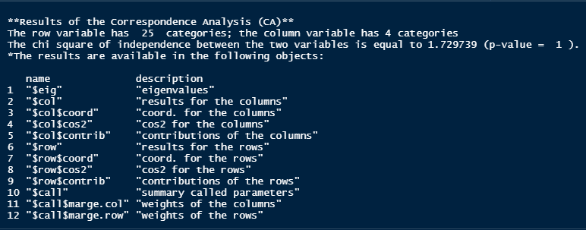

```{R}

# Statistical Significance

# Chi

Chi1 <- 1785.433

# Degree of Freedom

DF1 <- (1/(nrow(achieve)-1))*100

DF1

DF1.1 <- (1/(ncol(achieve)-1))*100

DF1.1

#P-Value

PVal1 <- pchisq(Chi1, df = DF1, lower.tail = FALSE)

PVal1

```



```{R}

# EigenValues & Variances

ach.ca.eig <- ach.ca$eig

ach.ca.eig

fviz_screeplot(ach.ca, addlabels = TRUE, ylim = c(0, 60))

fviz_screeplot(ach.ca)+geom_hline(yintercept = DF1.1, linetype = 4, color = "black")

```

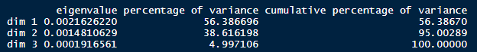

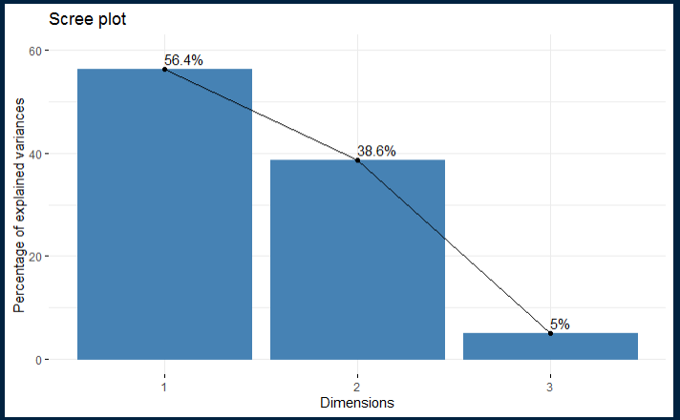

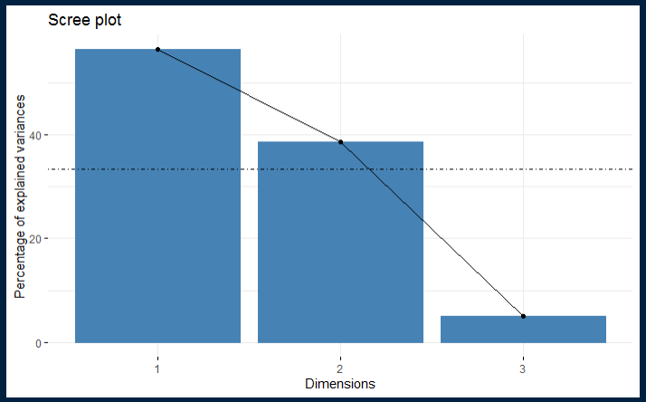

```{R}

# biplot

fviz_ca_biplot(ach.ca, repel = TRUE)

```

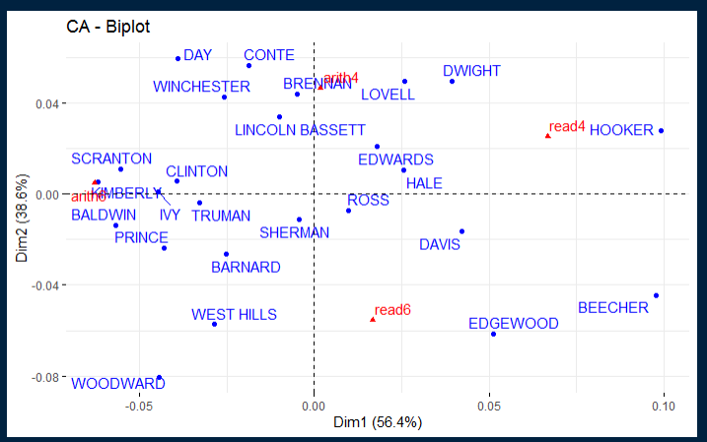

```{R}

# Graph of Row Variable

ach.ca.row <- ach.ca$row

ach.ca.row

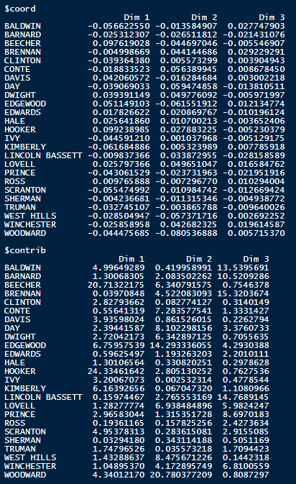

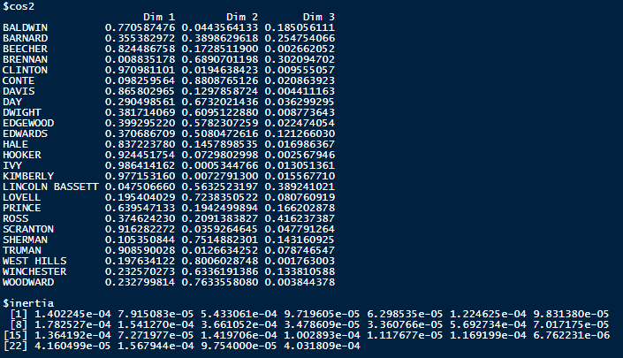

# Visual Row Variables

# Coord

fviz_ca_row(ach.ca, col.row = "coord", gradient.cols = c("#00AFBB", "#E7B800", "#FC4E07"), repel = TRUE)

corrplot(ach.ca.row$coord, is.corr = FALSE)

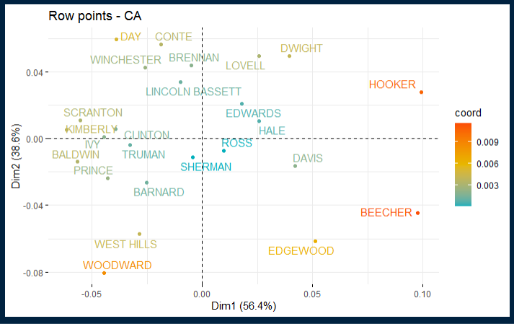

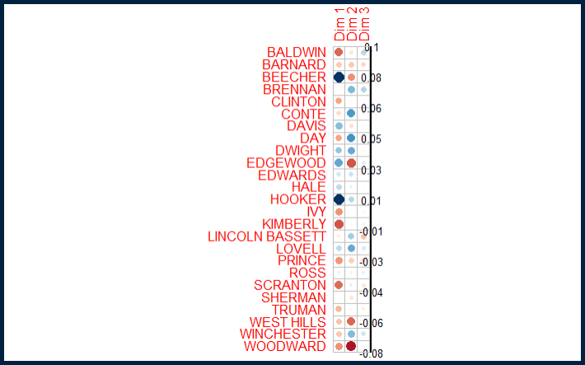

# Cos2

fviz_ca_row(ach.ca, col.row = "cos2", gradient.col = c("#00AFBB", "#E7B800", "#FC4E07"), repel = TRUE)

corrplot(ach.ca.row$cos2, is.corr = FALSE)

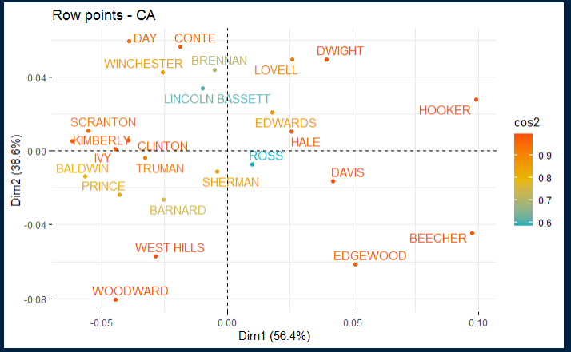

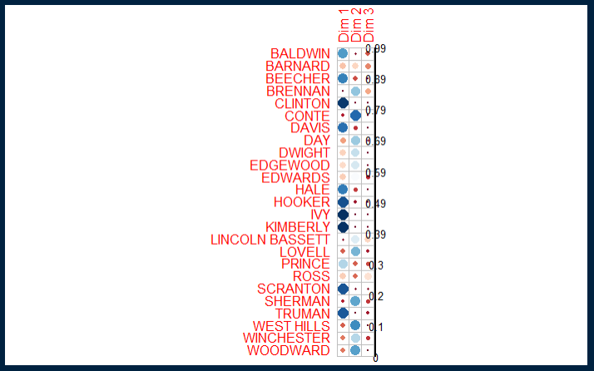

#Contrib

fviz_ca_row(ach.ca, col.row = "contrib", gradient.col = c("#00AFBB", "#E7B800", "#FC4E07"), repel = TRUE)

corrplot(ach.ca.row$contrib, is.corr = FALSE)

```

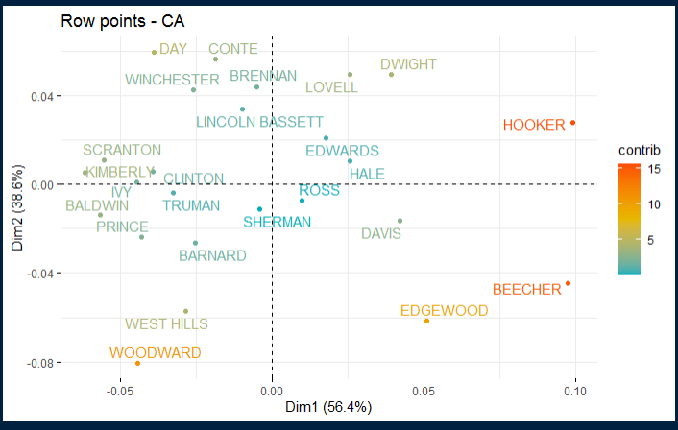

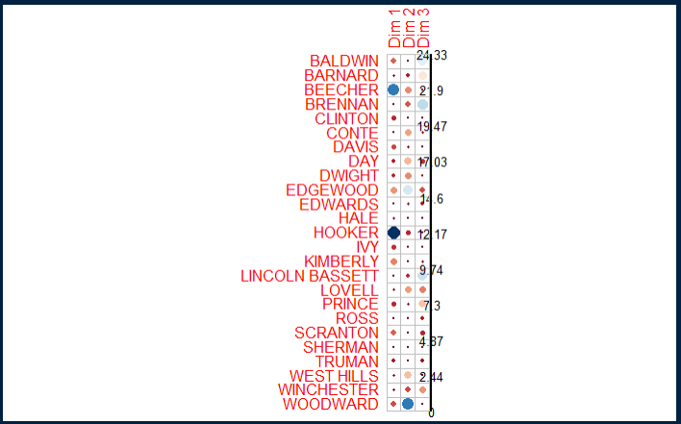

```{R}

# Graph of Column Variables

ach.ca.col <- ach.ca$col

ach.ca.col

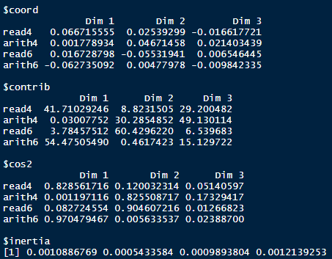

# Visual Row Variables

# Coord

fviz_ca_col(ach.ca, col.col = "coord", gradient.cols = c("#00AFBB", "#E7B800", "#FC4E07"), repel = TRUE)

corrplot(ach.ca.col$coord, is.corr = FALSE)

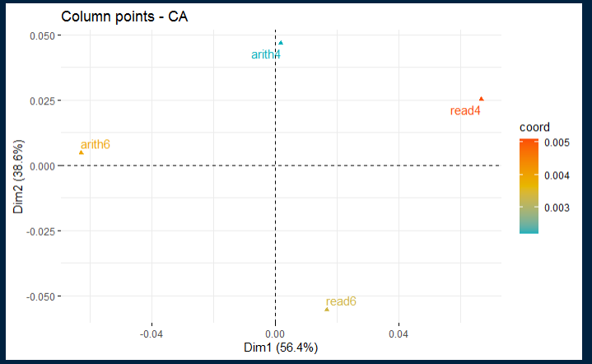

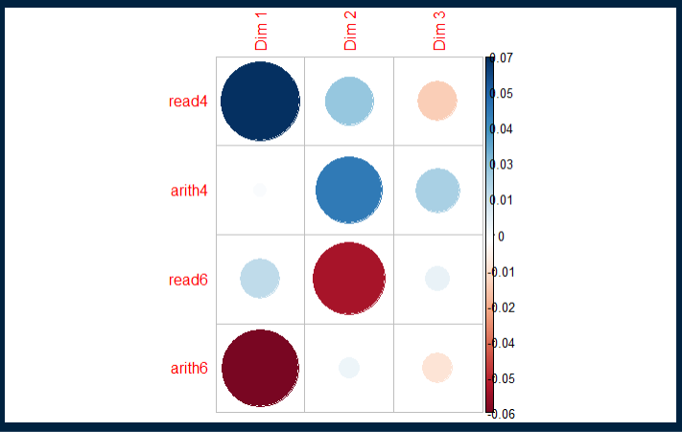

# Cos2

fviz_ca_col(ach.ca, col.col = "cos2", gradient.col = c("#00AFBB", "#E7B800", "#FC4E07"), repel = TRUE)

corrplot(ach.ca.col$cos2, is.corr = FALSE)

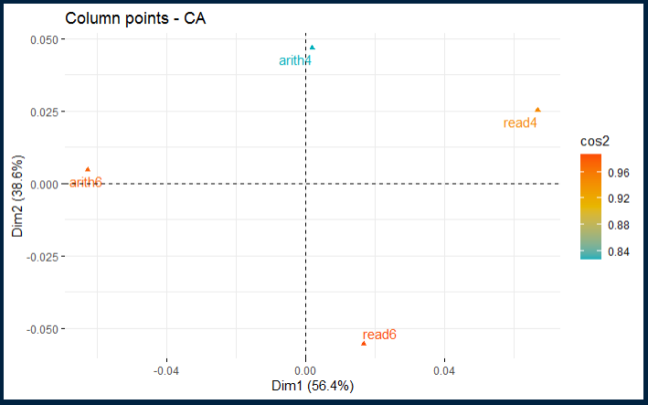

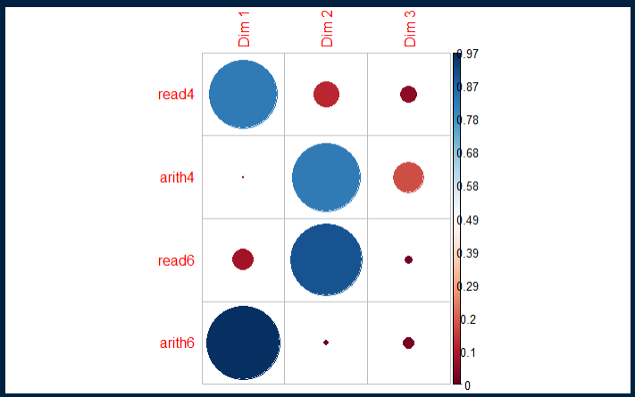

#Contrib

fviz_ca_col(ach.ca, col.col = "contrib", gradient.col = c("#00AFBB", "#E7B800", "#FC4E07"), repel = TRUE)

corrplot(ach.ca.col$contrib, is.corr = FALSE)

```

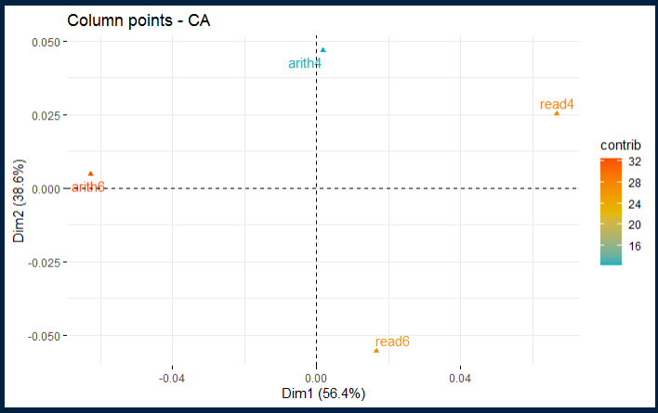

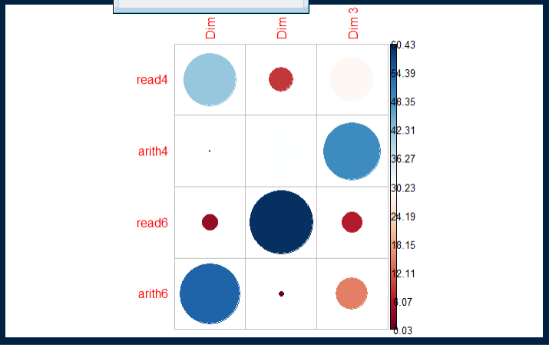

```{R}

# Biplot Options

# Asymmetric Biplot

fviz_ca_biplot(ach.ca, map ="rowprincipal", arrow = c(TRUE, TRUE), repel = TRUE)

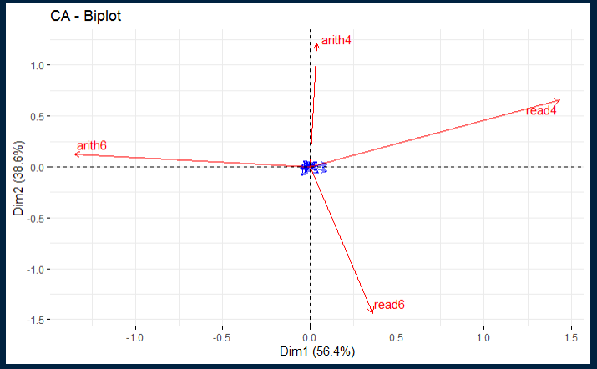

#Contribution Biplot

fviz_ca_biplot(ach.ca, map = "colgreen", arrow = c(TRUE, TRUE), repel = TRUE)

```

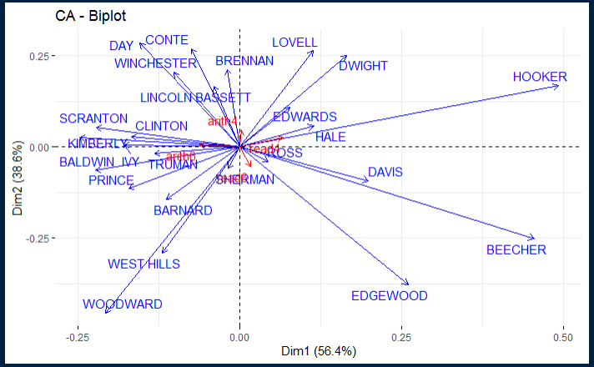

```{R}

#Dimension Description

ach.desc <- dimdesc(ach.ca, axes = c(1, 2))

ach.desc

```

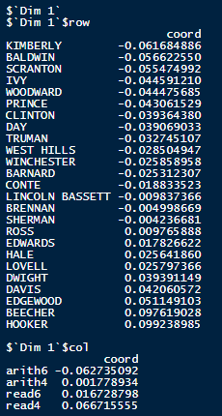 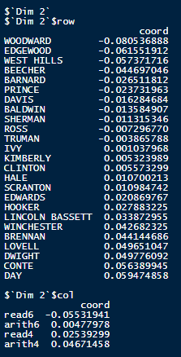

```{R}

# Dataset 2

# Preparation

library(flexclust)

library(FactoMineR)

library(factoextra)

library(corrplot)

# CA

data("VADeaths")

va.ca <- CA(VADeaths, graph = FALSE)

va.ca

```

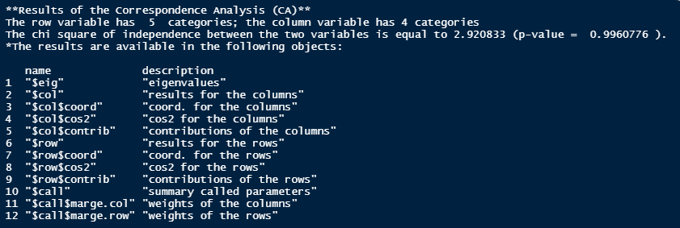

```{R}

# Statistical Significance

# Chi

Chi2 <- 1502.556

# Degree of Freedom

DF2<- (1/(nrow(VADeaths)-1))*100

DF2

DF2.1 <- (1/(ncol(VADeaths)-1))*100

DF2.1

#P-Value

PVal2 <- pchisq(Chi2, df = DF2, lower.tail = FALSE)

PVal2

```



```{R}

# EigenValues & Variances

va.ca.eig <- va.ca$eig

va.ca.eig

fviz_screeplot(va.ca, addlabels = TRUE, ylim = c(0, 85))

fviz_screeplot(va.ca)+geom_hline(yintercept = DF2.1, linetype = 4, color = "black")

```

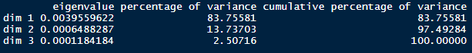

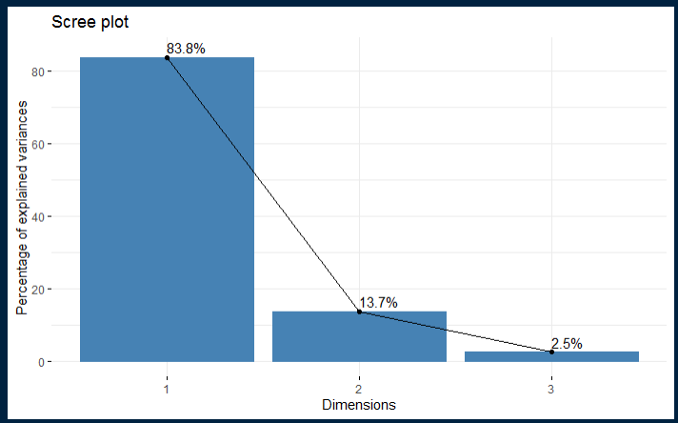

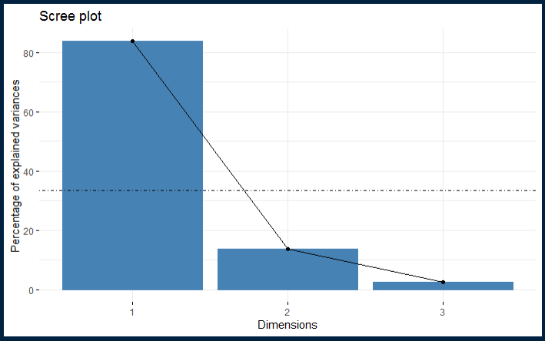

```{R}

# biplot

fviz_ca_biplot(va.ca, repel = TRUE)

```

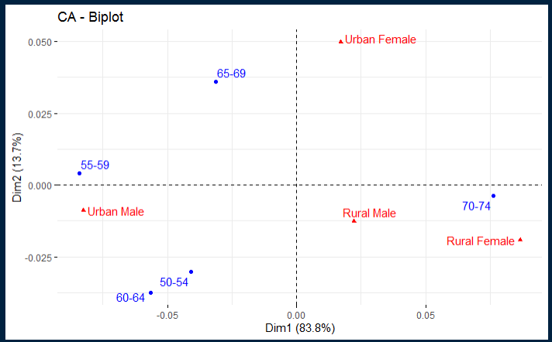

```{R}

# Graph of Row Variable

va.ca.row <- va.ca$row

va.ca.row

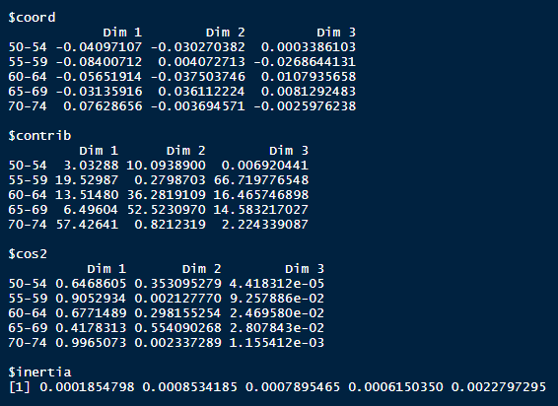

# Visual Row Variables

# Coord

fviz_ca_row(va.ca, col.row = "coord", gradient.cols = c("#00AFBB", "#E7B800", "#FC4E07"), repel = TRUE)

corrplot(va.ca.row$coord, is.corr = FALSE)

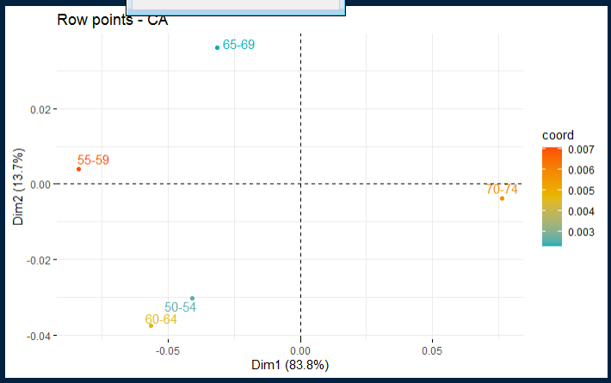

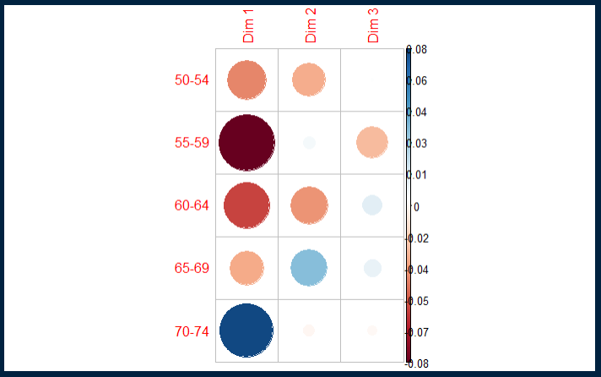

# Cos2

fviz_ca_row(va.ca, col.row = "cos2", gradient.col = c("#00AFBB", "#E7B800", "#FC4E07"), repel = TRUE)

corrplot(va.ca.row$cos2, is.corr = FALSE)

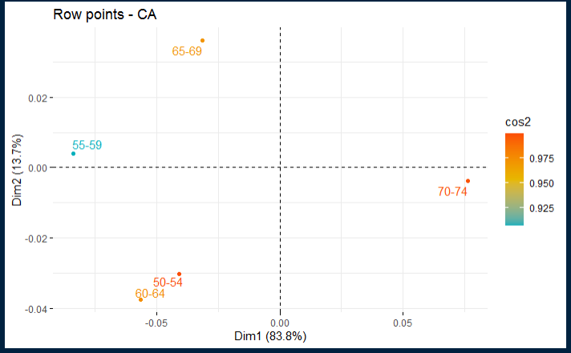

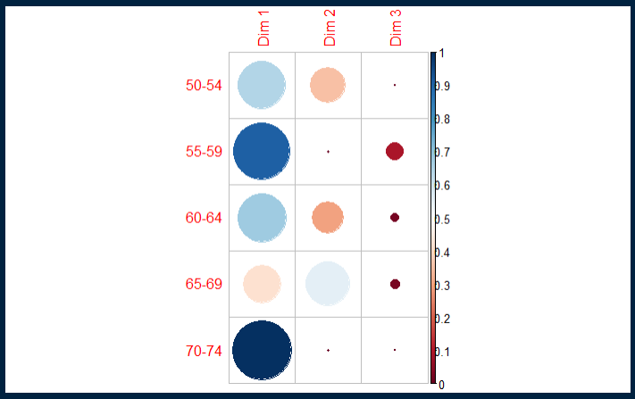

#Contrib

fviz_ca_row(va.ca, col.row = "contrib", gradient.col = c("#00AFBB", "#E7B800", "#FC4E07"), repel = TRUE)

corrplot(va.ca.row$contrib, is.corr = FALSE)

```

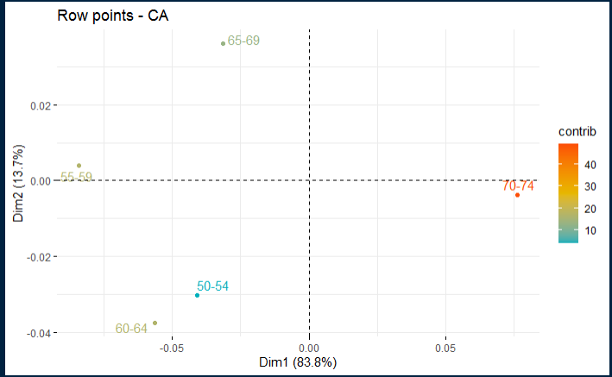

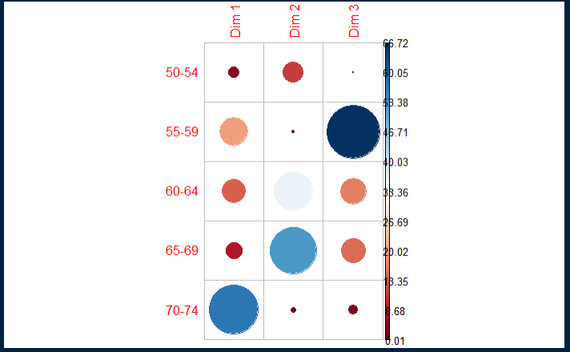

```{R}

# Graph of Column Variables

va.ca.col <- va.ca$col

va.ca.col

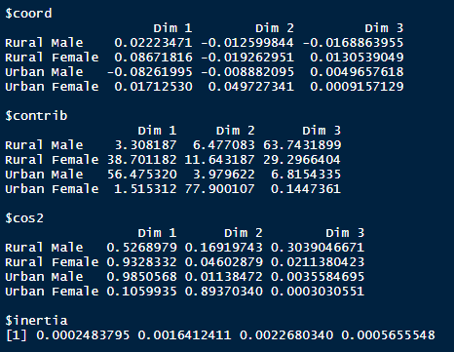

# Visual Row Variables

# Coord

fviz_ca_col(va.ca, col.col = "coord", gradient.cols = c("#00AFBB", "#E7B800", "#FC4E07"), repel = TRUE)

corrplot(va.ca.col$coord, is.corr = FALSE)

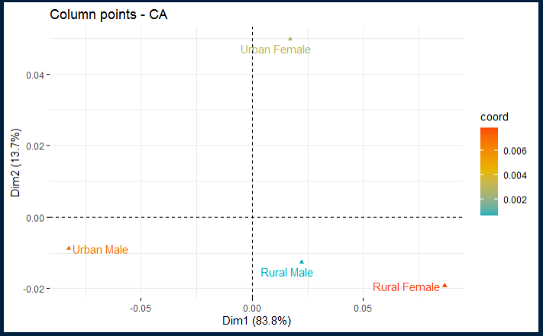

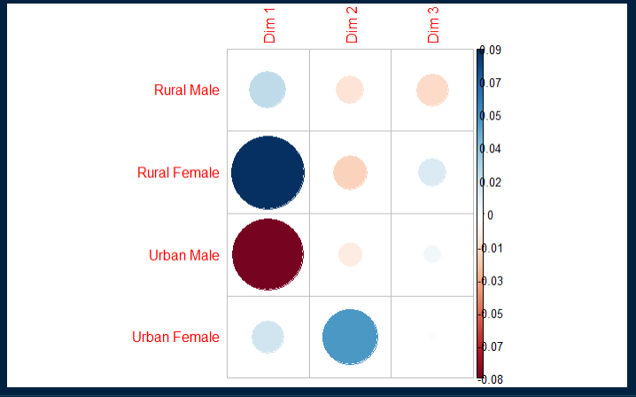

# Cos2

fviz_ca_col(va.ca, col.col = "cos2", gradient.col = c("#00AFBB", "#E7B800", "#FC4E07"), repel = TRUE)

corrplot(va.ca.col$cos2, is.corr = FALSE)

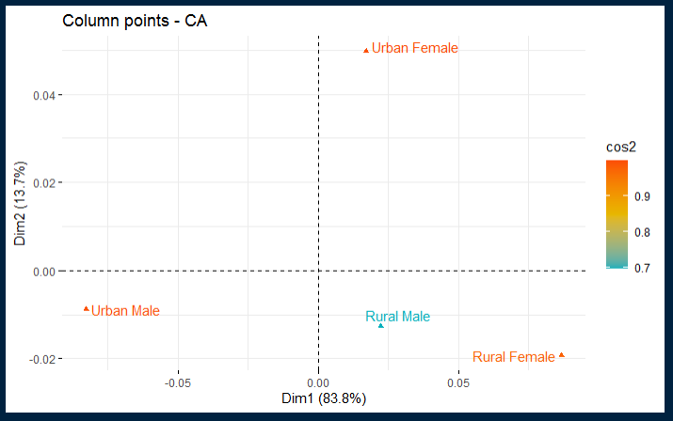

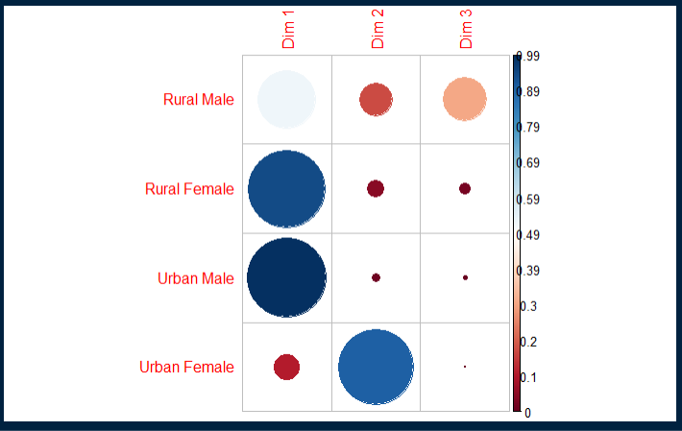

#Contrib

fviz_ca_col(va.ca, col.col = "contrib", gradient.col = c("#00AFBB", "#E7B800", "#FC4E07"), repel = TRUE)

corrplot(va.ca.col$contrib, is.corr = FALSE)

```

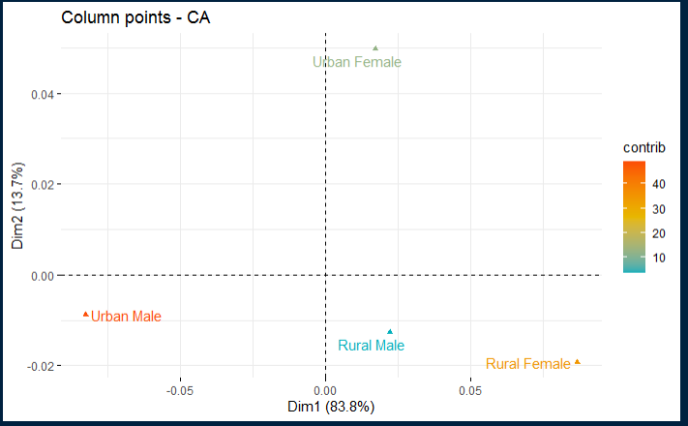

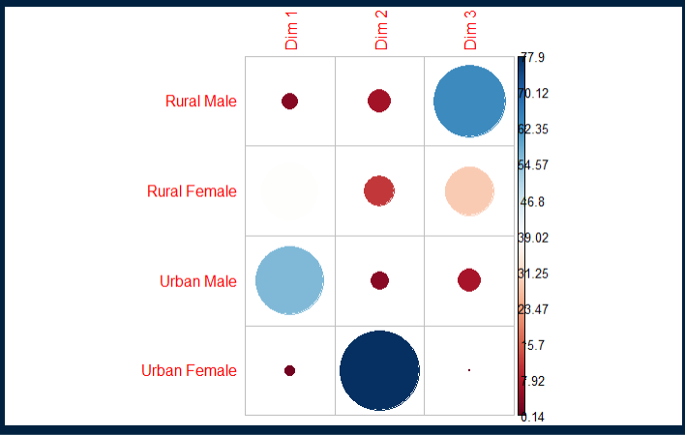

```{R}

# Biplot Options

# Asymmetric Biplot

fviz_ca_biplot(va.ca, map ="rowprincipal", arrow = c(TRUE, TRUE), repel = TRUE)

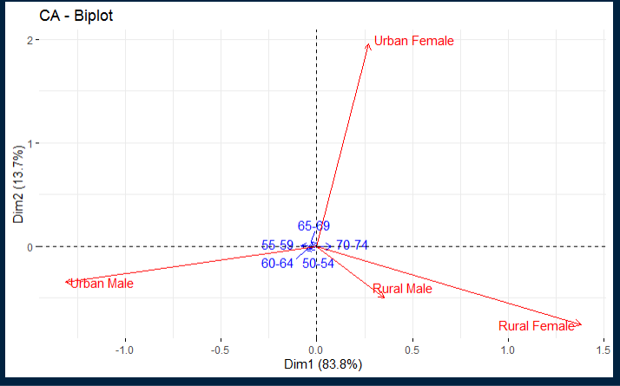

#Contribution Biplot

fviz_ca_biplot(va.ca, map = "colgreen", arrow = c(TRUE, TRUE), repel = TRUE)

```

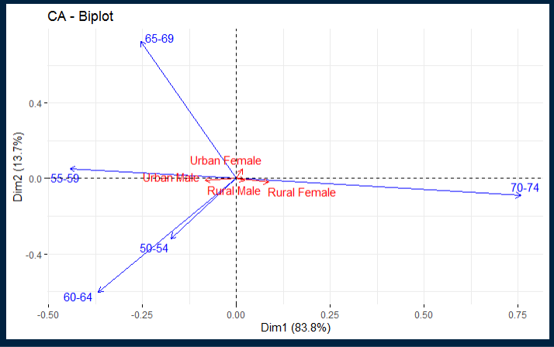

```{R}

#Dimension Description

va.desc <- dimdesc(va.ca, axes = c(1, 2))

va.desc

```

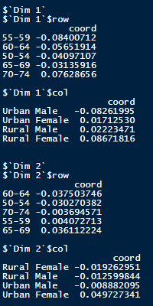

```{R}

# Dataset 3

# Statistical Significance

# Chi

Chi3 <- 2198.241

# Degree of Freedom

DF3 <- (1/(nrow(housetasks)-1))*100

DF3

DF3.1 <- (1/(ncol(housetasks)-1))*100

DF3.1

#P-Value

PVal3 <- pchisq(Chi3, df = DF3, lower.tail = FALSE)

PVal3

```



```{R}

# EigenValues & Variances

ht.ca.eig <- ht.ca$eig

ht.ca.eig

fviz_screeplot(ht.ca, addlabels = TRUE, ylim = c(0, 95))

fviz_screeplot(ht.ca)+geom_hline(yintercept = DF3.1, linetype = 4, color = "black")

```

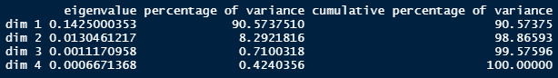

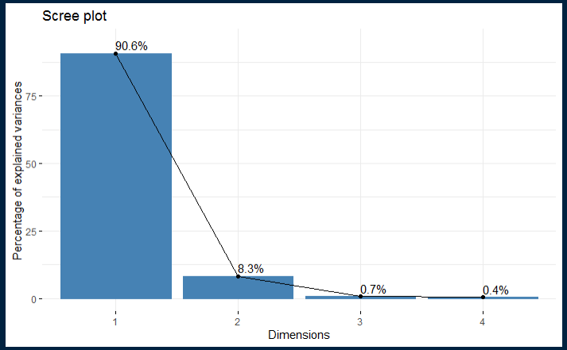

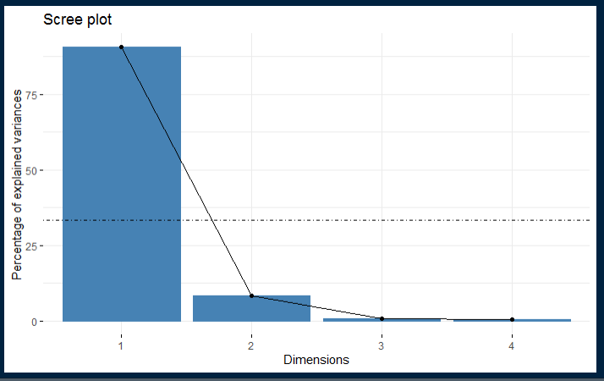

```{R}

# biplot

fviz_ca_biplot(ht.ca, repel = TRUE)

```

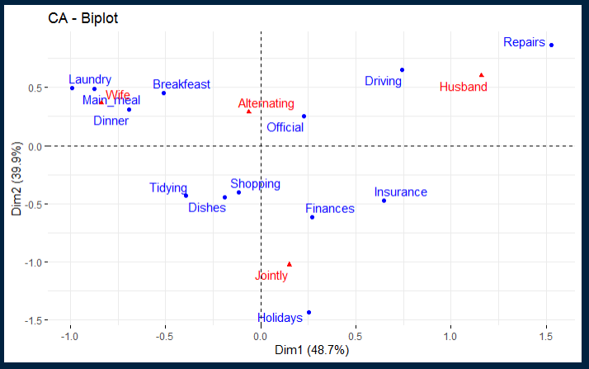

```{R}

# Graph of Row Variable

ht.ca.row <- ht.ca$row

ht.ca.row

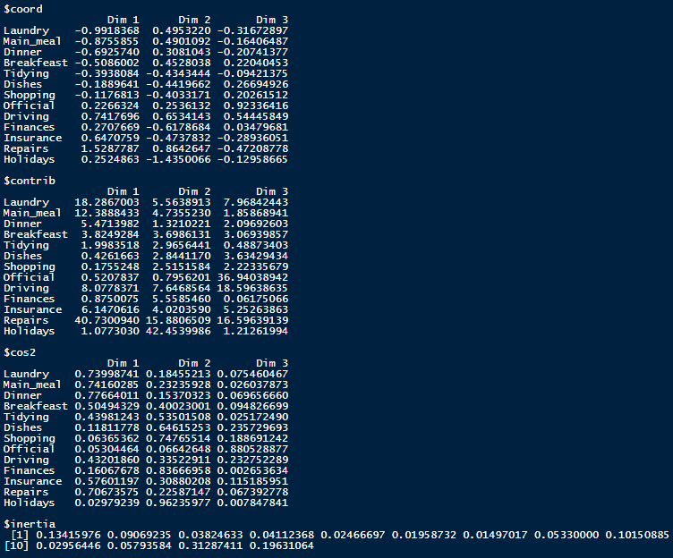

# Visual Row Variables

# Coord

fviz_ca_row(ht.ca, col.row = "coord", gradient.cols = c("#00AFBB", "#E7B800", "#FC4E07"), repel = TRUE)

corrplot(ht.ca.row$coord, is.corr = FALSE)

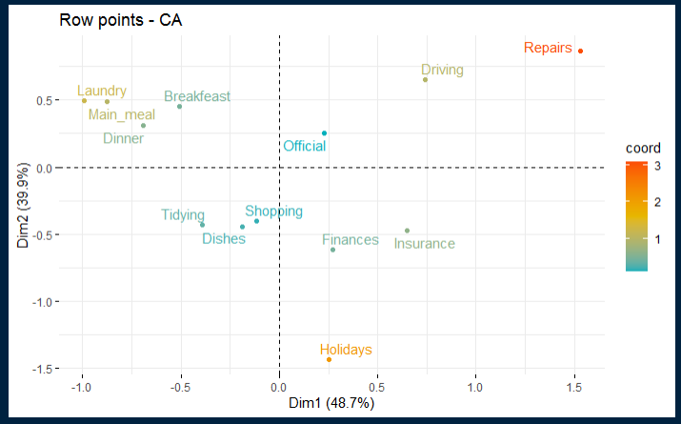

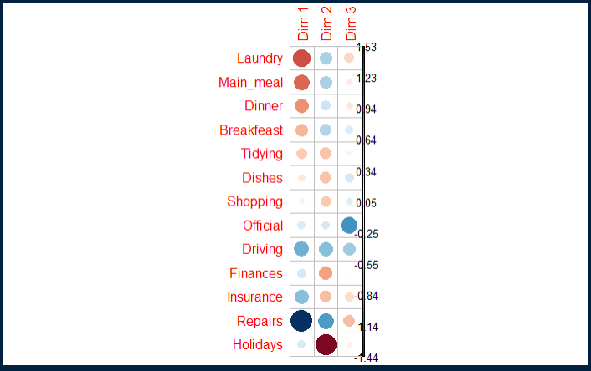

# Cos2

fviz_ca_row(ht.ca, col.row = "cos2", gradient.col = c("#00AFBB", "#E7B800", "#FC4E07"), repel = TRUE)

corrplot(ht.ca.row$cos2, is.corr = FALSE)

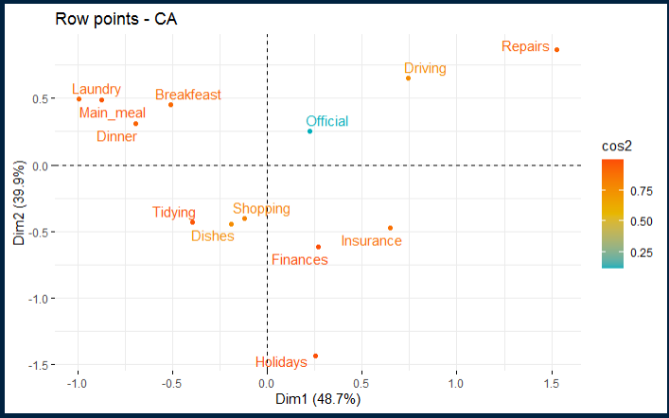

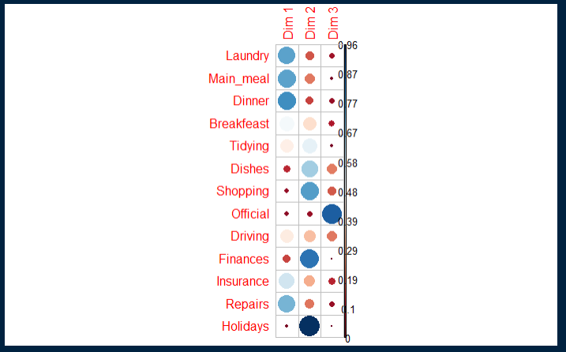

#Contrib

fviz_ca_row(ht.ca, col.row = "contrib", gradient.col = c("#00AFBB", "#E7B800", "#FC4E07"), repel = TRUE)

corrplot(ht.ca.row$contrib, is.corr = FALSE)

```

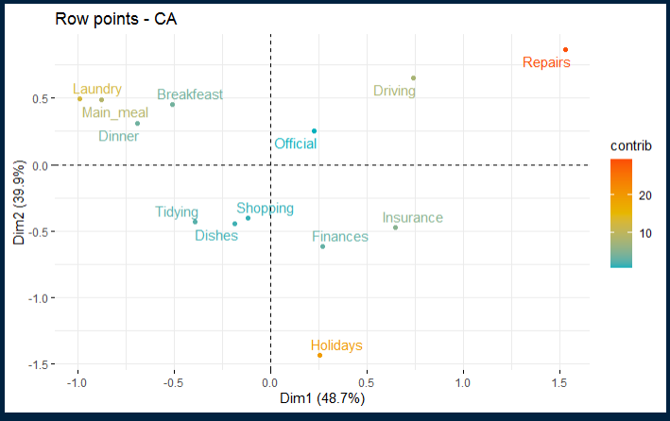

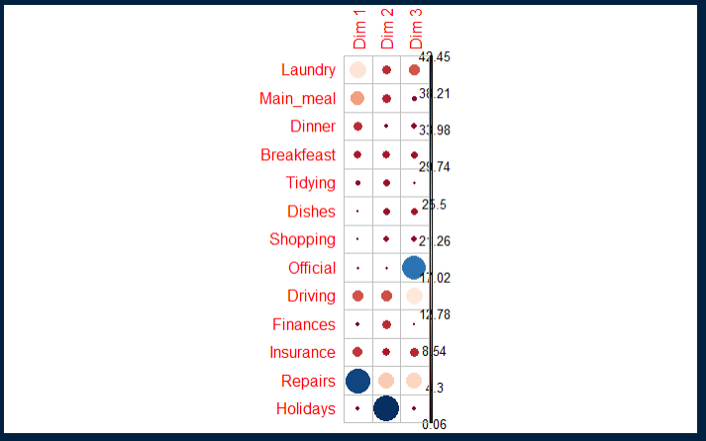

```{R}

# Graph of Column Variables

ht.ca.col <- ht.ca$col

ht.ca.col

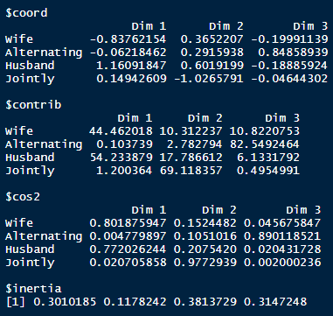

# Visual Row Variables

# Coord

fviz_ca_col(ht.ca, col.col = "coord", gradient.cols = c("#00AFBB", "#E7B800", "#FC4E07"), repel = TRUE)

corrplot(ht.ca.col$coord, is.corr = FALSE)

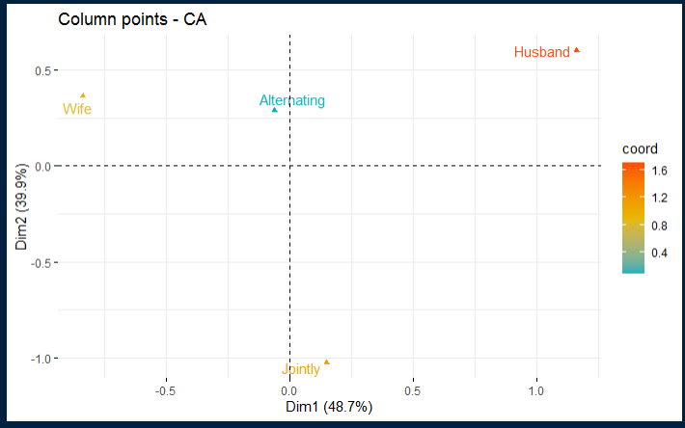

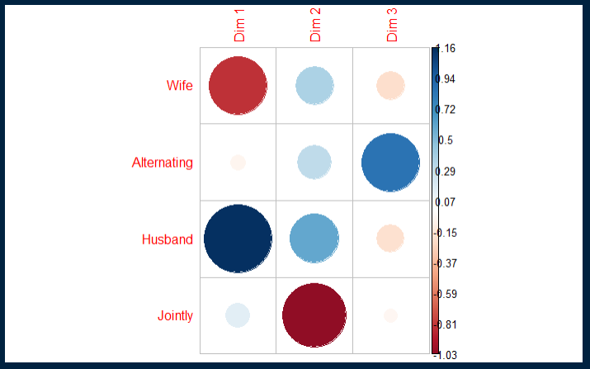

# Cos2

fviz_ca_col(ht.ca, col.col = "cos2", gradient.col = c("#00AFBB", "#E7B800", "#FC4E07"), repel = TRUE)

corrplot(ht.ca.col$cos2, is.corr = FALSE)

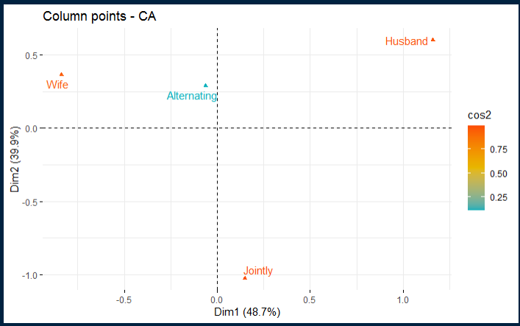

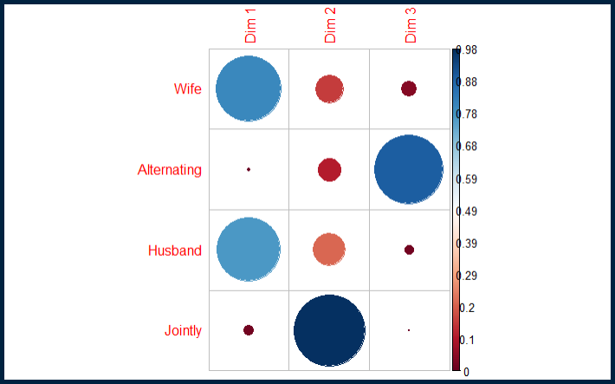

#Contrib

fviz_ca_col(ht.ca, col.col = "contrib", gradient.col = c("#00AFBB", "#E7B800", "#FC4E07"), repel = TRUE)

corrplot(ht.ca.col$contrib, is.corr = FALSE)

```

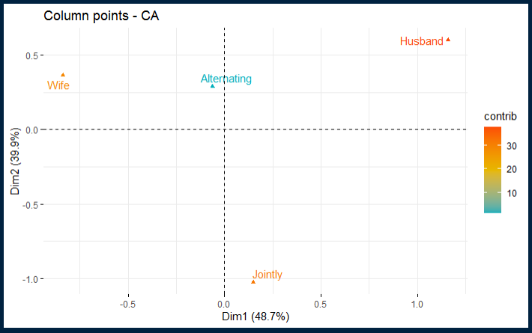

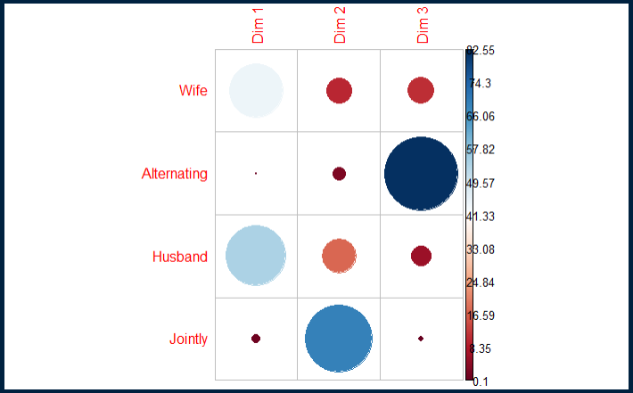

```{R}

# Biplot Options

# Asymmetric Biplot

fviz_ca_biplot(ht.ca, map ="rowprincipal", arrow = c(TRUE, TRUE), repel = TRUE)

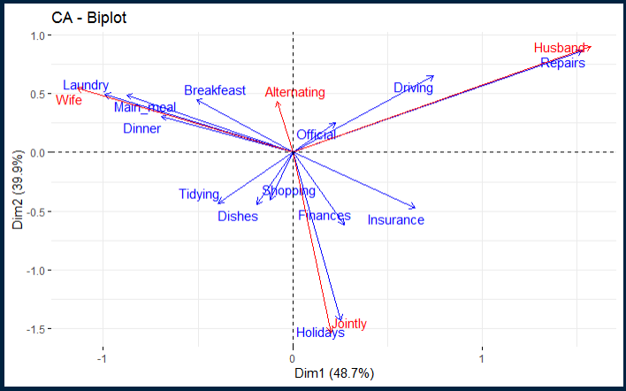

#Contribution Biplot

fviz_ca_biplot(ht.ca, map = "colgreen", arrow = c(TRUE, TRUE), repel = TRUE)

```

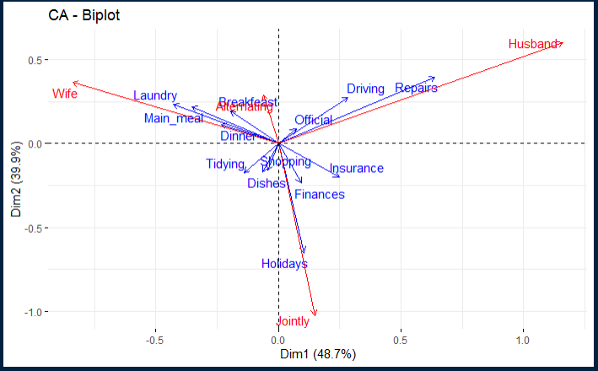

```{R}

#Dimension Description

ht.desc <- dimdesc(ht.ca, axes = c(1, 2))

ht.desc

```

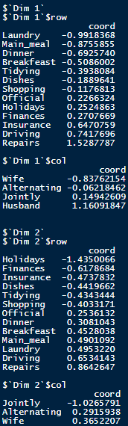

```{R}

# Dataset 1

mca1 <- data("USMortality")

mca1 <- USMortality[, c("Status", "Sex", "Cause")]

mca1

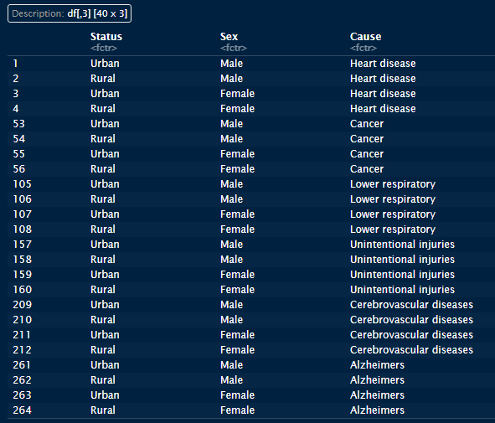

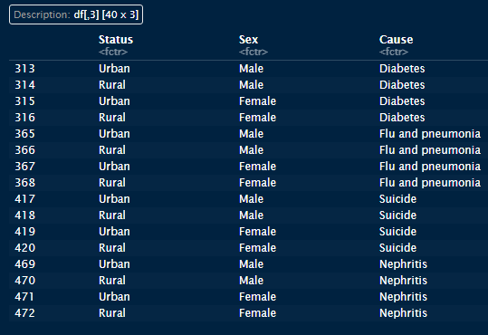

# MCA

USM <- MCA(mca1, graph = FALSE)

USM

```

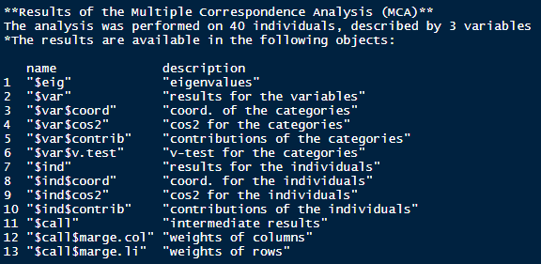

```{R}

# Eigen Values / Variances

USM$eig

fviz_screeplot(USM, addlabels = TRUE, ylim = c(0, 15))

```

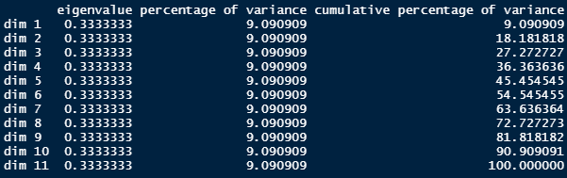

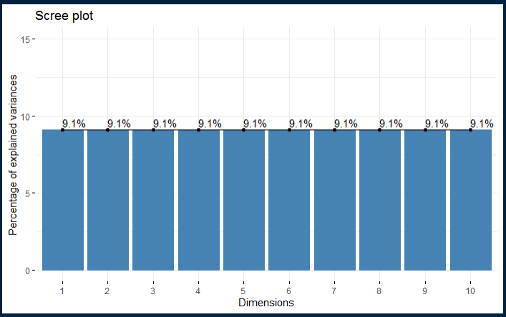

```{R}

# Biplot

fviz_mca_biplot(USM, axes = c(5, 5), repel = TRUE)

```

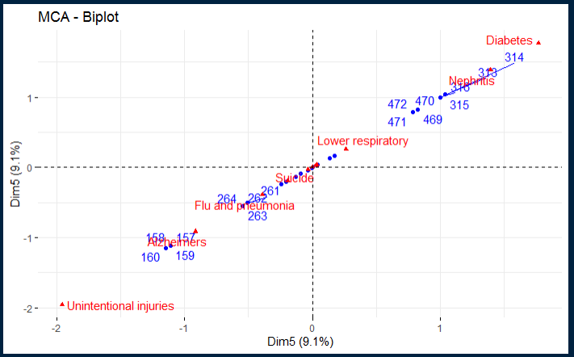

```{R}

# Graph of Variables

USM$var

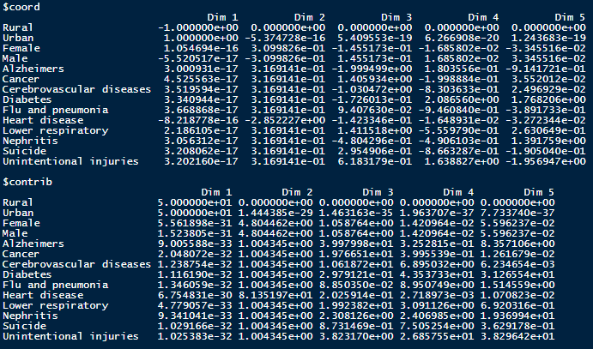

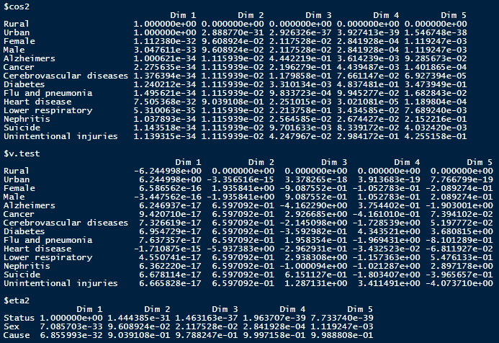

# Coord

fviz_mca_var(USM, col.var = "coord", gradient.cols = c("#00AFBB", "#E7B800", "#FC4E07"), axes = c(5, 5), repel = TRUE)

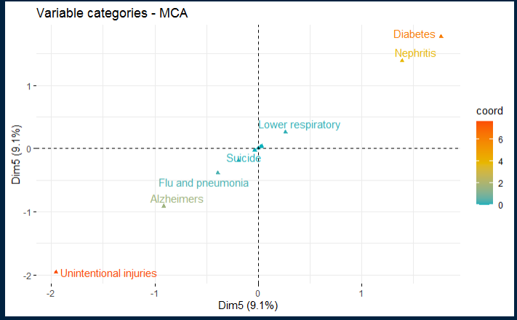

# Cos2

fviz_mca_var(USM, col.var = "cos2", gradient.cols = c("#00AFBB", "#E7B800", "#FC4E07"), axes = c(5, 5), repel = TRUE)

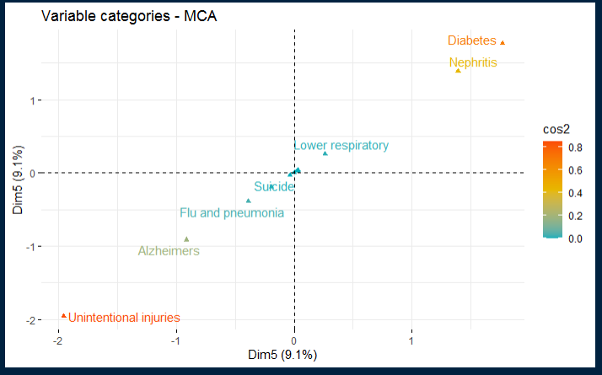

# Contrib

fviz_mca_var(USM, col.var = "contrib", gradient.cols = c("#00AFBB", "#E7B800", "#FC4E07"), axes = c(5, 5), repel = TRUE)

```

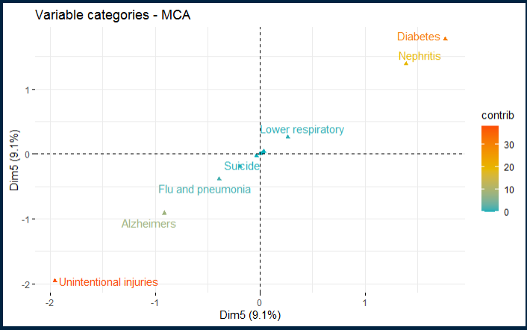

```{R}

# Graph of Individuals

USM$ind

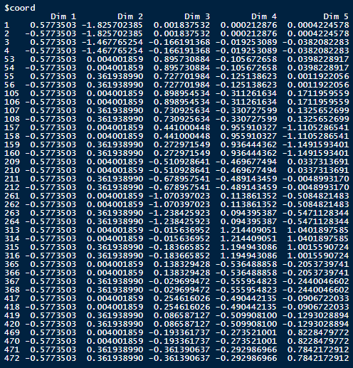

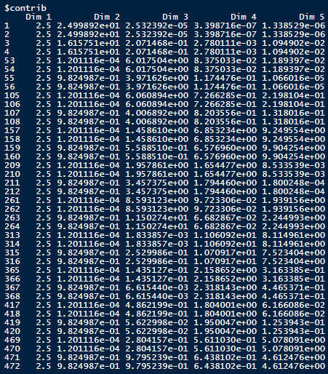

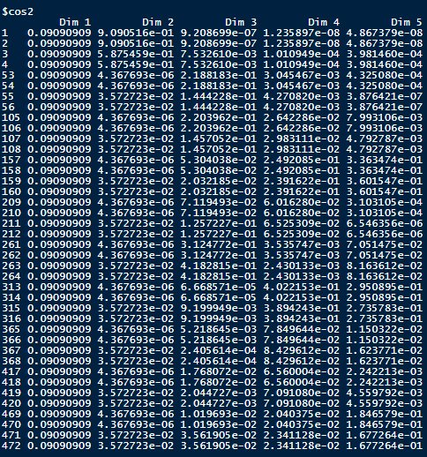

# Coord

fviz_mca_ind(USM, col.ind = "coord", gradient.cols = c("#00AFBB", "#E7B800", "#FC4E07"), axes = c(5, 5), repel = TRUE)

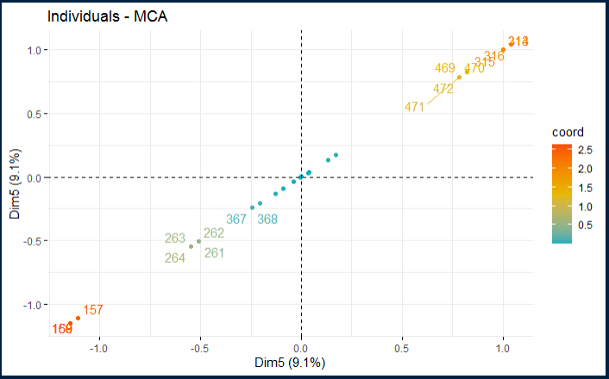

# Cos2

fviz_mca_ind(USM, col.ind = "cos2", gradient.cols = c("#00AFBB", "#E7B800", "#FC4E07"), axes = c(5, 5), repel = TRUE)

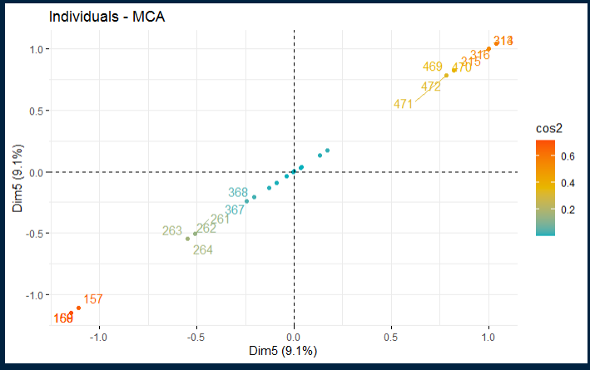

# Contrib

fviz_mca_ind(USM, col.ind = "contrib", gradient.cols = c("#00AFBB", "#E7B800", "#FC4E07"), axes = c(5, 5), repel = TRUE)

```

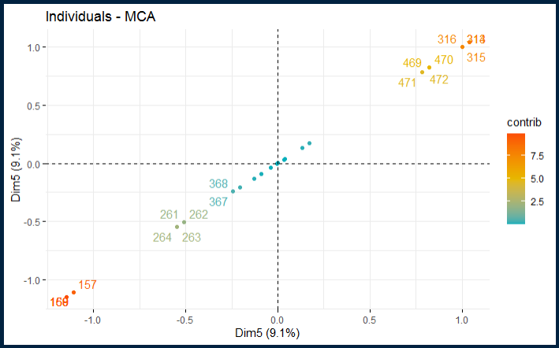

```{R}

# Color Individuals by Group

fviz_ellipses(USM, c("Sex", "Cause"))

```

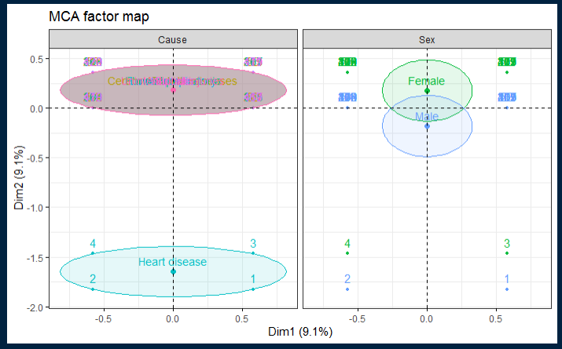

```{R}

# Dimension Desctiptions

USM.desc <- dimdesc(USM, axes = c(1,2))

USM.desc

```

